## 

## **For eel? It's Nintendo Society News Time!**

In case you missed it (because of exams, or other means):

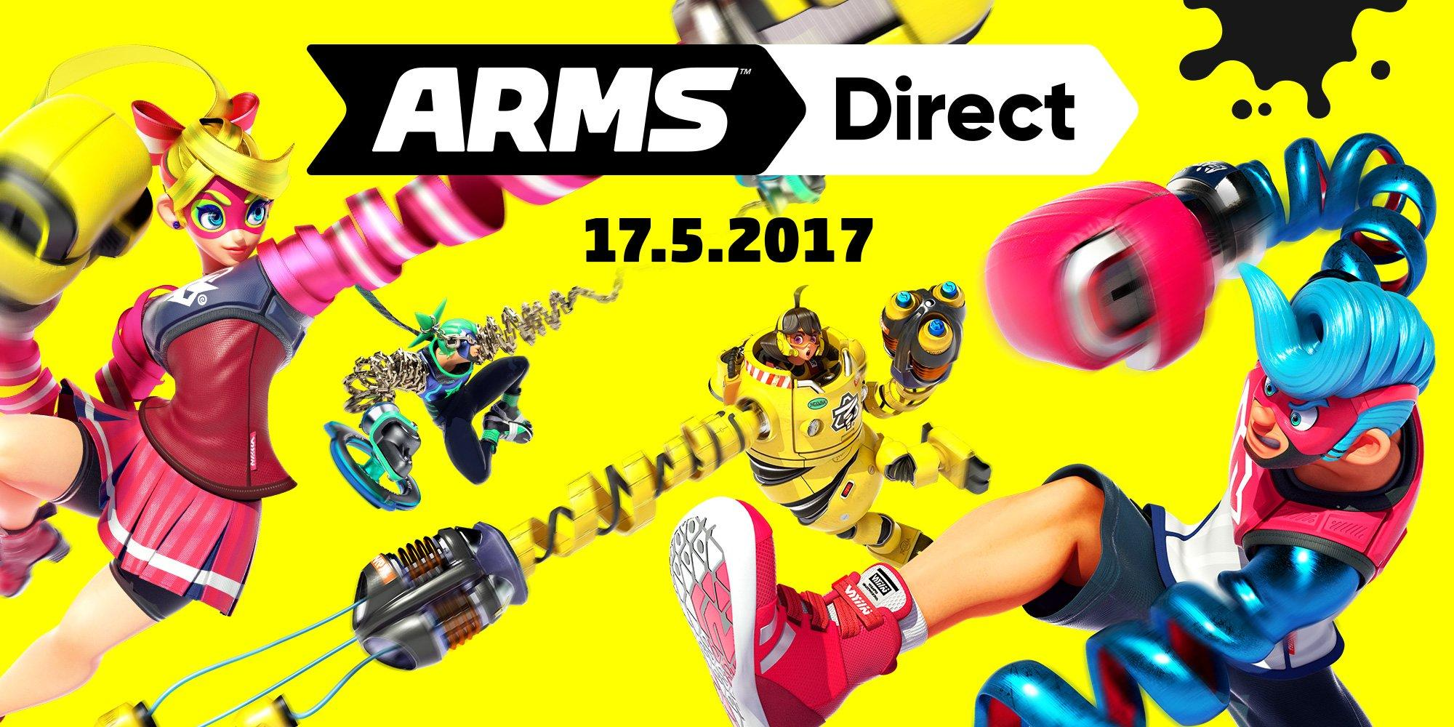

A Nintendo Direct dedicated to ARMS (with a splash of Splatoon 2 too!) aired last Wednesday and can be watched with this link: <https://www.youtube.com/watch?v=Av1SprijHe8>

ARMS will debut at our events near the end of term (hopefully) so watch out!

And with that, here is this week's announcement:

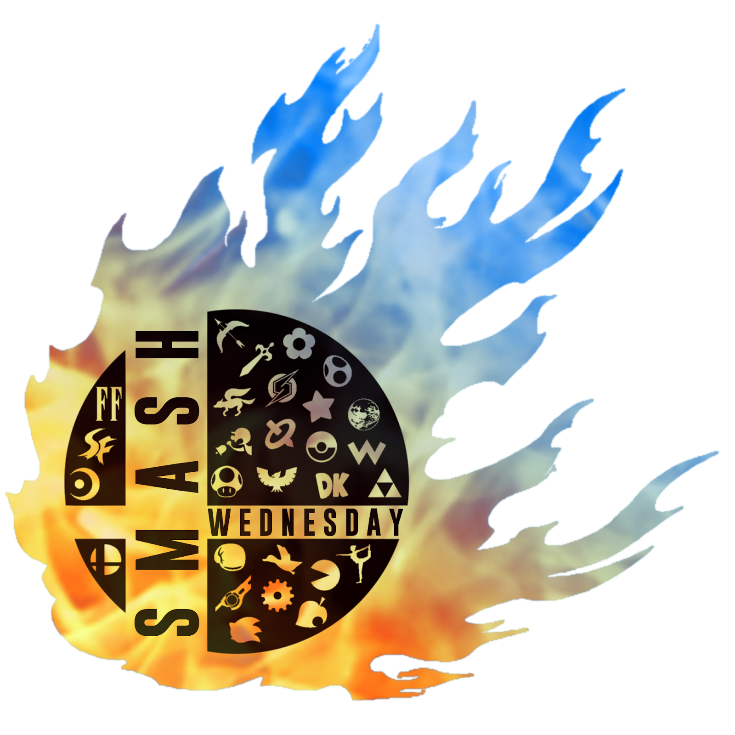

### **Wednesday 24/5, R1.04, 3pm onwards**

Our weekly Smash event returns! With a possibility of more competitive action! Come along to destress from term 3 revision and have fun!

---------------------------------------------------------------------------------------

Well then, folks, until next time, staaaay fresh!

And Happy Gaming! :D

Timothy Sit

Nintendo Society President

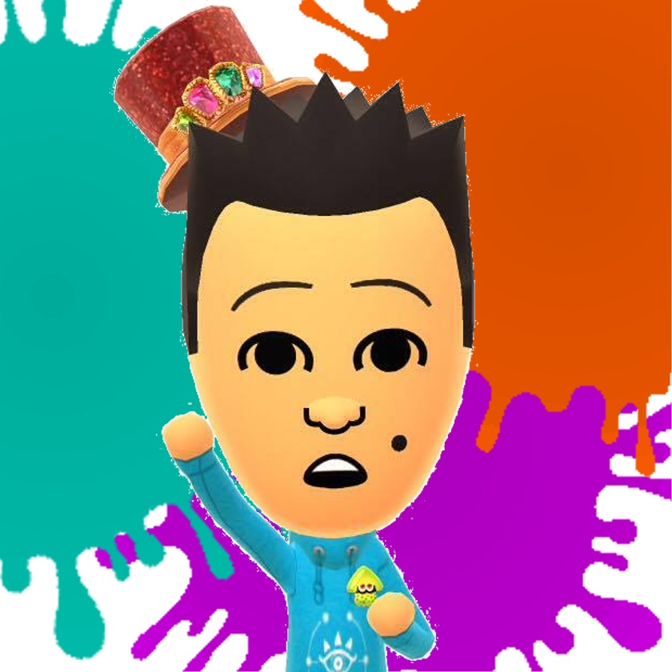

---------------------------------------------------------------------------------------

### **Find us on Social Media:**

Join our Facebook group:<https://www.facebook.com/groups/warwicknintendo/>

Follow our Twitter:<https://twitter.com/warwicknintendo>

Join our Discord Chat:<https://discordapp.com/invite/Rf6QyfG>

Subscribe to our YouTube:<https://www.youtube.com/channel/UCzO_bZNfQDCAQa_zkEUgGVg>